Some optimizations for OTS 3.2

Summary
- Add 2 new features: Remake Order(s) and Duplicate Order(s)
- Update layout styles of print shipping marks (highlight some important things)
- No need to select again when updating order status in bulk
(especially when there are multiple products in one order)
- Toggle checkbox should only on checkbox zone instead of whole line

Specific details
- Add 2 new features: Remake Order and Duplicate Order
  - Step 1: Select order(s)
We can select the orders that need to be Remake or Duplicate (multiple choices are possible).
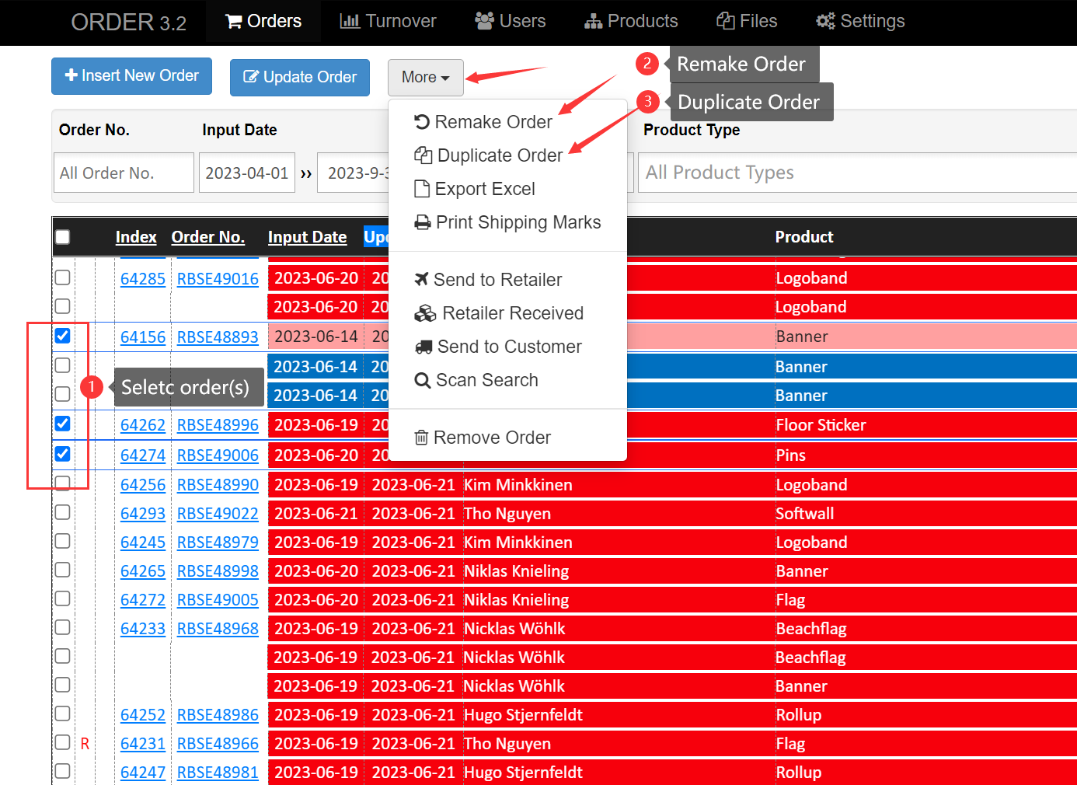

  - Step 2: Confirm Remake/Duplicate order(s)
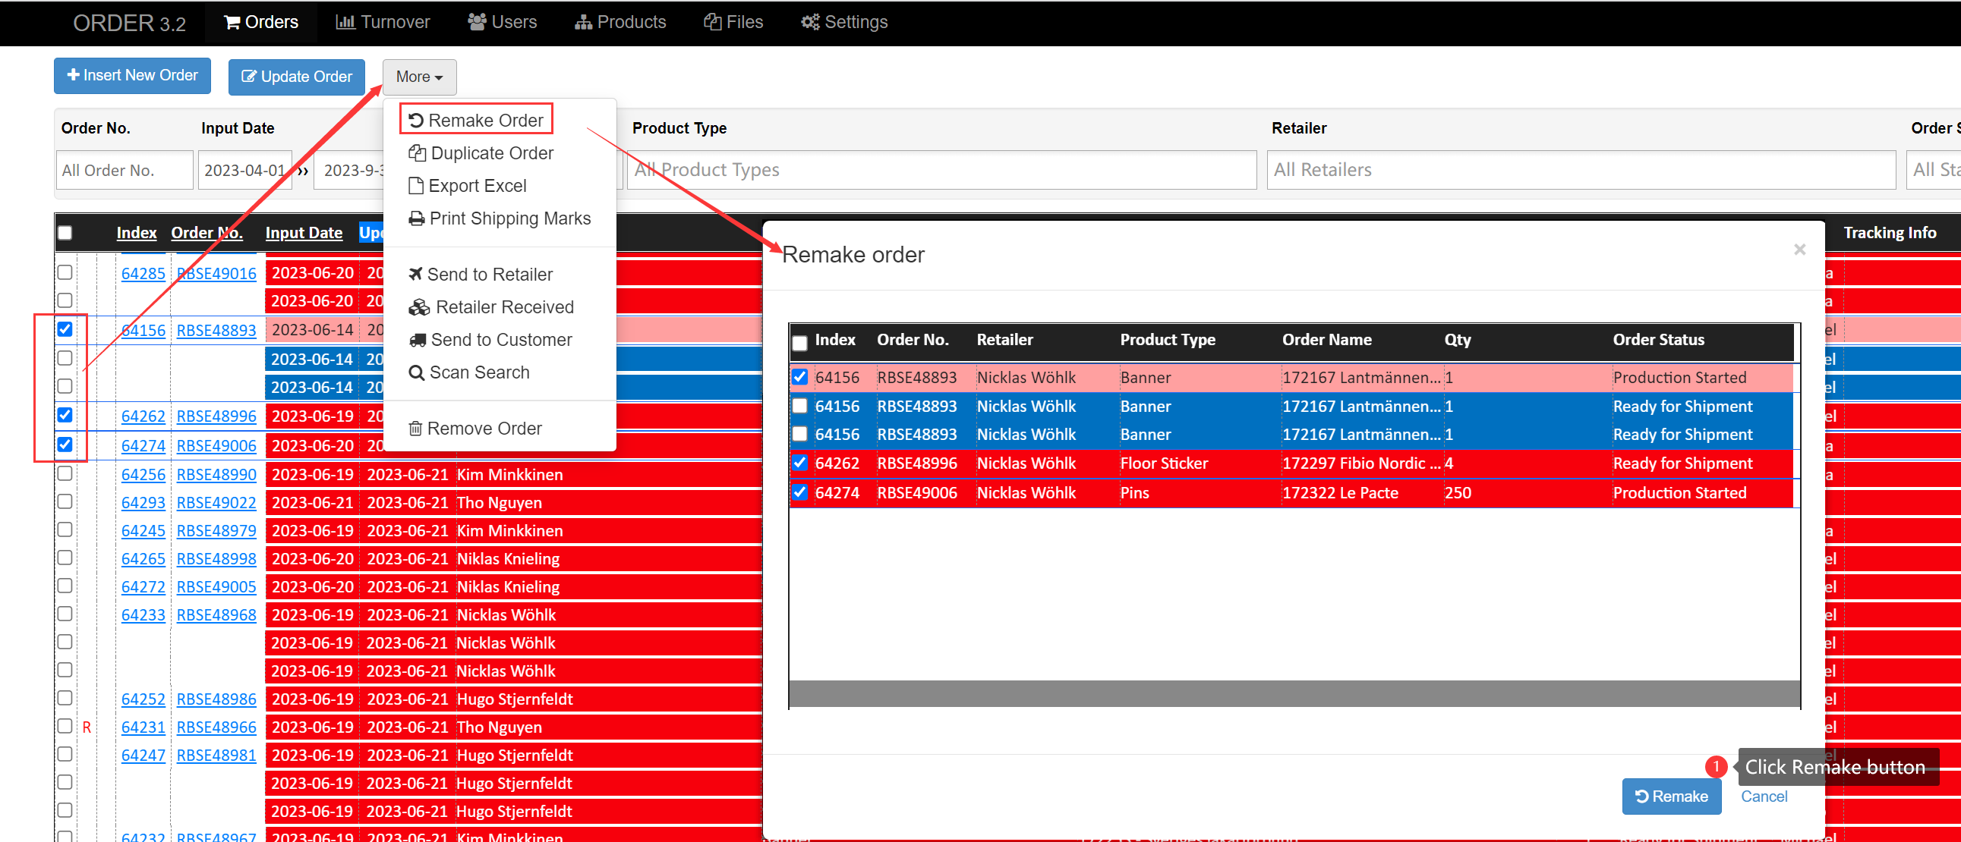

  - Step 3: Some details in the Remake/Duplicate order
Some of the information in the order after Remake or Duplicate has been reset and needs to be modified and saved manually (Especially the quantity of products when we need to fix).
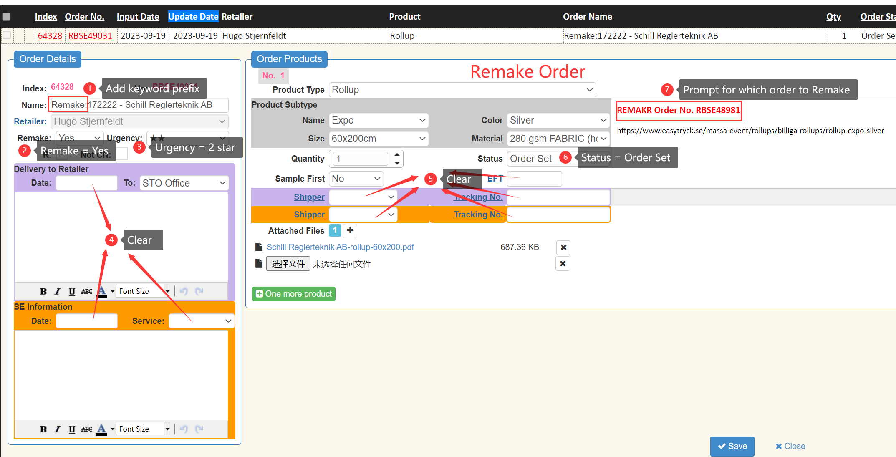
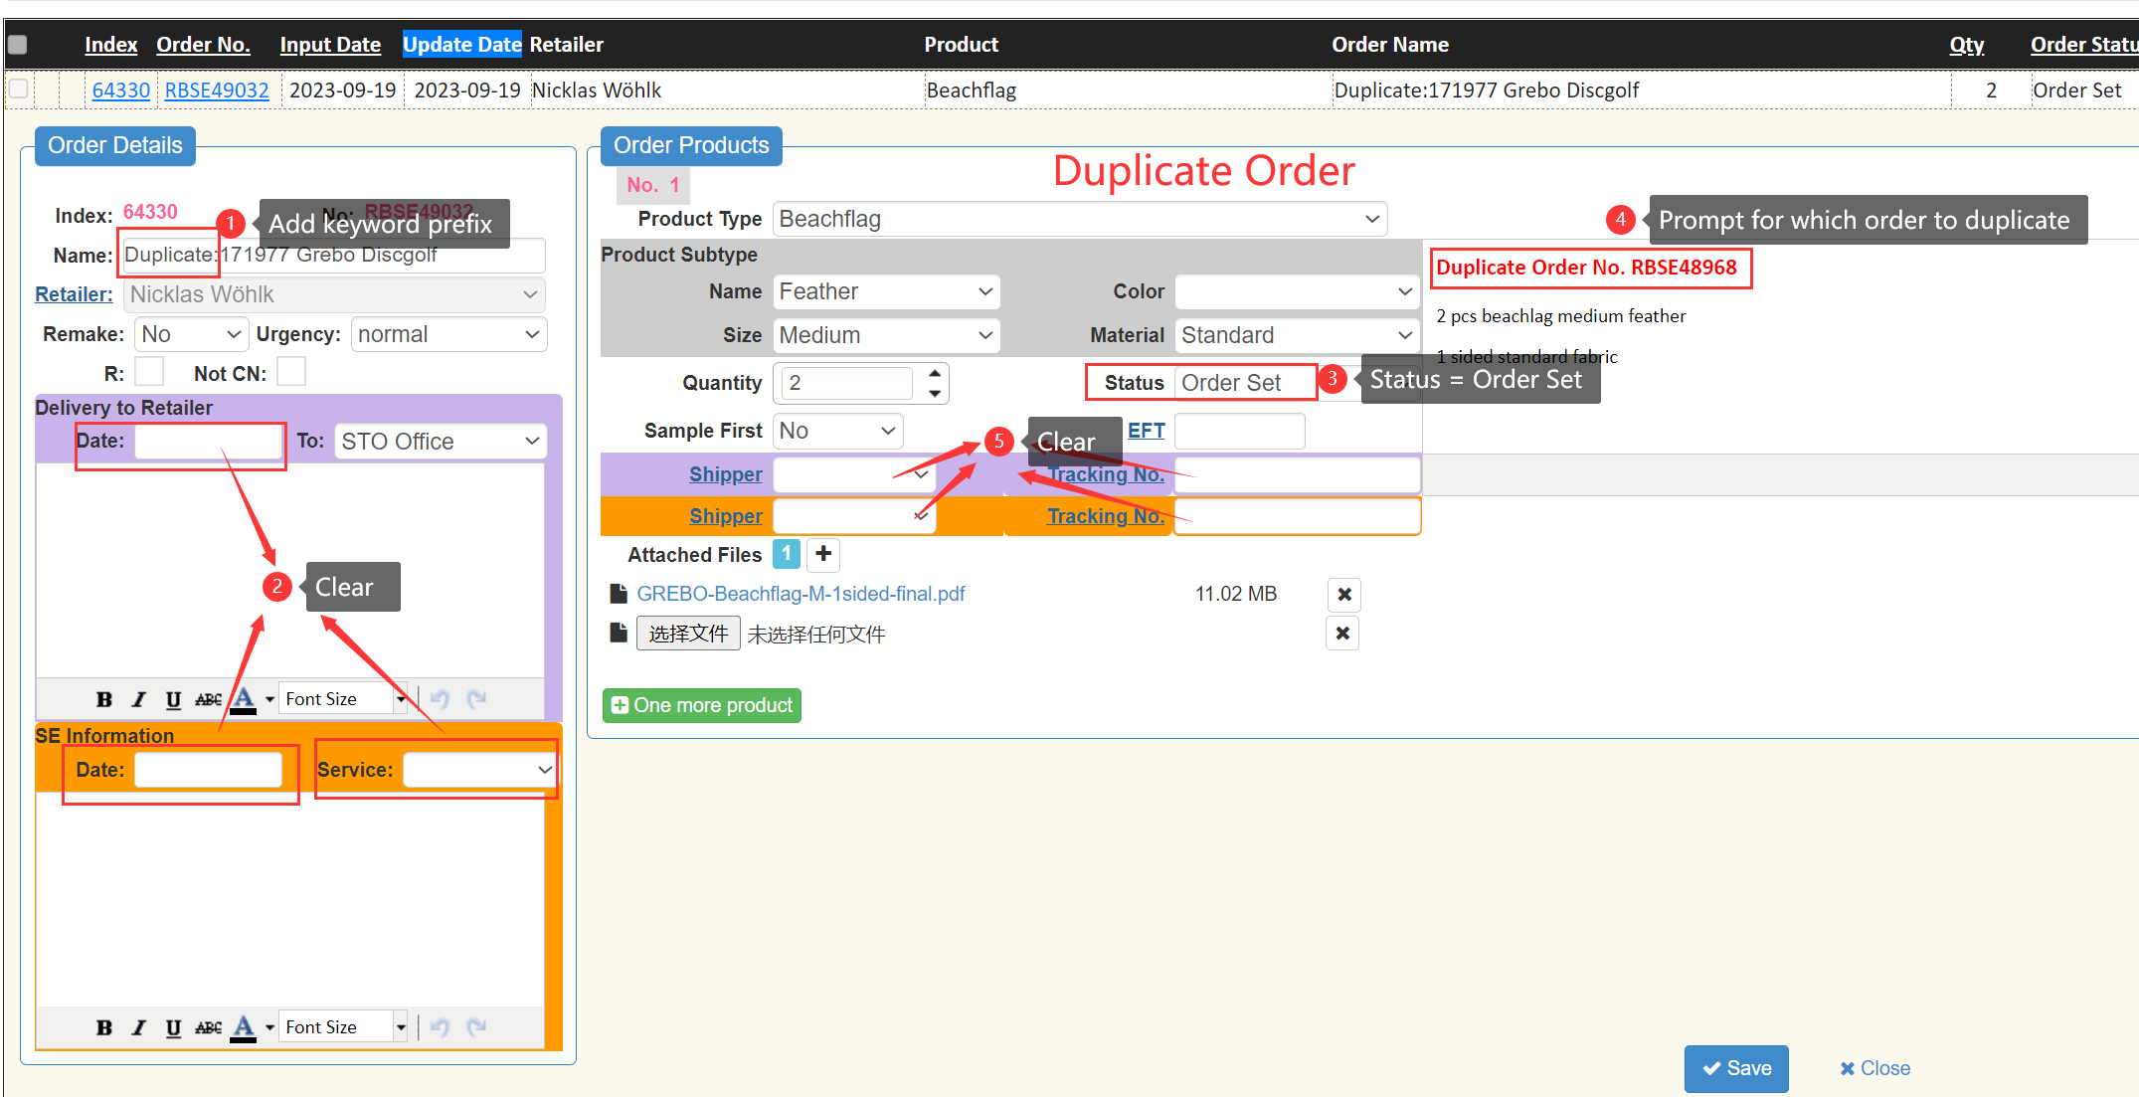
- Update the layout styles of print shipping marks (highlight some important things)
- If delivery to customer, Order Name becomes white with black background. No change is required for delivery to STO.
- The retailer’s name and ship time are in a separate column.
- Expanded font size for barcode value.
- When a sub-order is selected, the corresponding CTN column becomes white with a black background, and the quantity and product name are bolded.
- If the Lead time of the order is Express/Express+, then the Lead time section becomes white with black background.
- The lower right corner of the mark shows the “current order product no.”/”total of order products”.
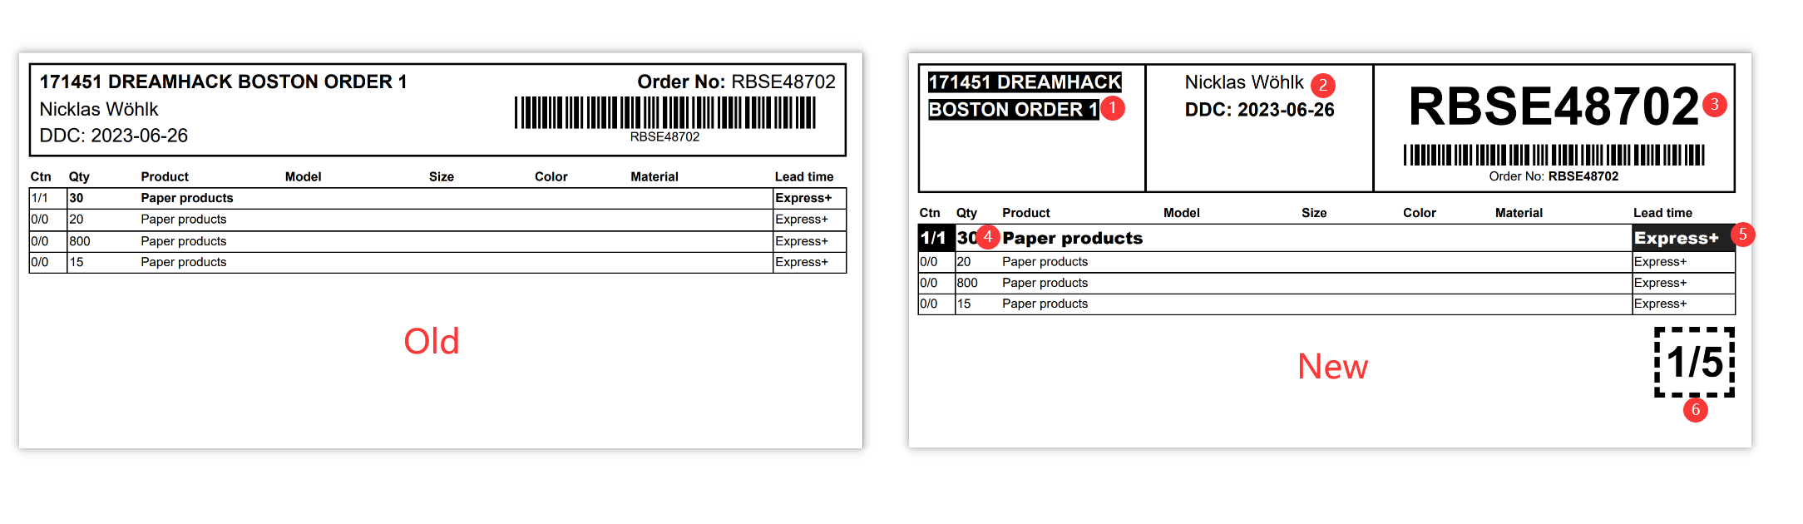
- No need to select again when updating order status in bulk
(especially when there are multiple products in one order)
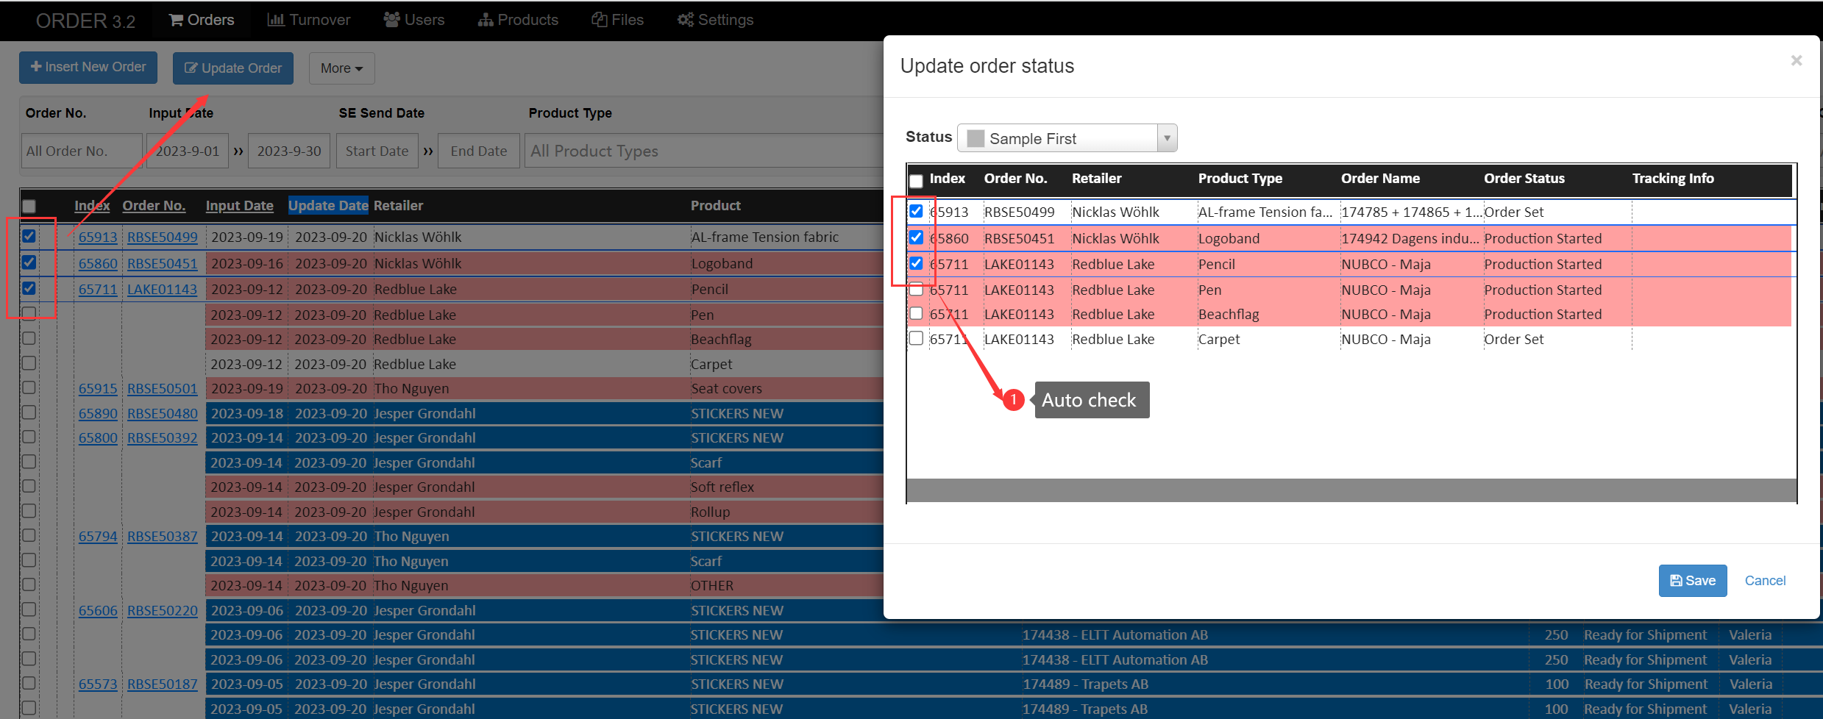

- Toggle checkbox should only on checkbox zone instead of whole line
